**Dimension(EON) | Progress Report — December 2019**

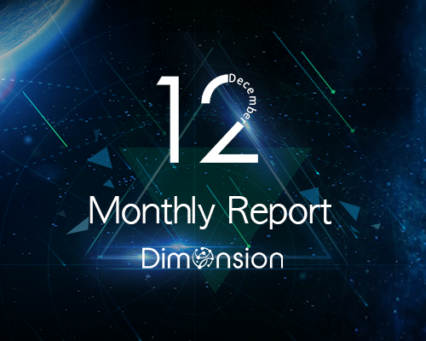

**Technical Progress**

**● System C.H.A.O.S.**

The three characteristic phases of the underlying technology are completed, supporting the middleware framework X-Gen

The network smoothly generates blocks according to different specified algorithms

Iterative development of the cross-consensus algorithm POW-C

**● Middleware Frame X-Gen**

Code implementation middleware payment module DePay

Middleware Data Access and Analysis Framework DataVision

Data Privacy and Data Attribute Management

**● Cross consensus engine Consensus-X**

Pre-research POW-C Proof Mechanism

Design support for cross-chain POW architecture